Project File: YouTube Video Downloader

**Project Overview:**

**YouTube Video Downloader** is a Python application that allows users to download videos from YouTube. It features a user-friendly graphical interface created with tkinter, and uses yt_dlp to handle video downloading. This project is ideal for those looking to understand basic GUI creation in Python and video downloading techniques.

**Use Case:**

This project is useful for individuals who want to save YouTube videos directly to their computer without needing to use a web-based tool. It provides a straightforward way to download videos in high quality by simply entering the video URL and selecting a save location.

**Explanation of Code:**

**Import and setup**

* tkinter: This is Python's standard library for creating graphical user interfaces (GUIs). It provides tools to create windows, buttons, labels, and other widgets.
* filedialog: A module within tkinter used to open file dialogs (e.g., for selecting folders).
* messagebox: Also part of tkinter, used to show pop-up messages (e.g., for errors or information).
* yt_dlp: A command-line tool and Python library used for downloading videos from YouTube and other video platforms. It is an updated fork of youtube-dl, which provides more features and fixes.

**GUI Part:**

The GUI part of the application is created using tkinter. Here’s a detailed breakdown:

1. **Creating the Main Window**

* + self.root.title("YouTube Video Downloader"): Sets the title of the main window.
  + self.root.geometry("600x400"): Specifies the size of the window (600 pixels wide and 400 pixels tall).
  + self.root.configure(bg='#f0f0f0'): Sets the background color of the window to a light gray (#f0f0f0).

1. **Adding Widgets**



* + Creates a frame (self.main_frame) within the main window with a white background (#ffffff), padding (padx and pady), and adds it to the window.



* Adds a label with the title of the application. The font is set to Arial, 24 pixels, bold, and the background is white.

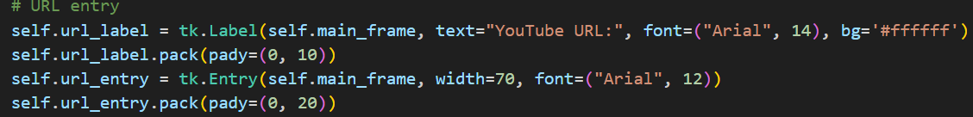

* + Adds a label for the URL entry field and the entry field itself where users can input the YouTube URL.



* + Adds a button for selecting the save location. The button’s background color is green (#4CAF50) with white text.

* + Adds a button to start the video download. The button’s background color is blue (#2196F3) with white text.

1. **Event Handlers**

* + Opens a file dialog to select a directory for saving the video. Shows a message box with the selected folder path.

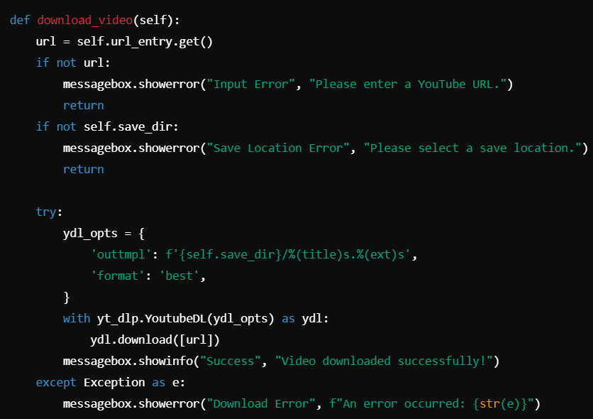

* + Handles the video download process. Checks if the URL and save directory are provided, and uses yt_dlp to download the video. Shows appropriate message boxes for success or error.

**yt_dlp Logic:**

The yt_dlp library handles the downloading of the video:

1. **Options Configuration**

* + outtmpl: Specifies the template for naming the downloaded file. %title% and %ext% are placeholders for the video title and file extension, respectively.
  + format: Sets the format to 'best', which downloads the highest quality available.

1. **Downloading the Video**

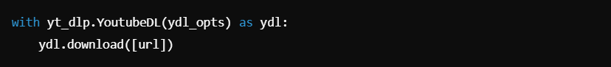

* + Creates an instance of YoutubeDL with the specified options and downloads the video from the given URL.